Question 1: Zero-Shot Prompting (Palindrome Number program)
Write a zero-shot prompt (without providing any examples) to generate a Python function that checks whether a given number is a palindrome.
Task:
- Record the AI-generated code.
- Test the code with multiple inputs.
- Identify any logical errors or missing edge-case handling.
PROMPT : Zero-Shot Prompt

> Write a Python function that checks whether a given number is a palindrome. The function should take an integer as input and return whether the number is a palindrome or not. Handle relevant edge cases and provide clear, simple Python code.
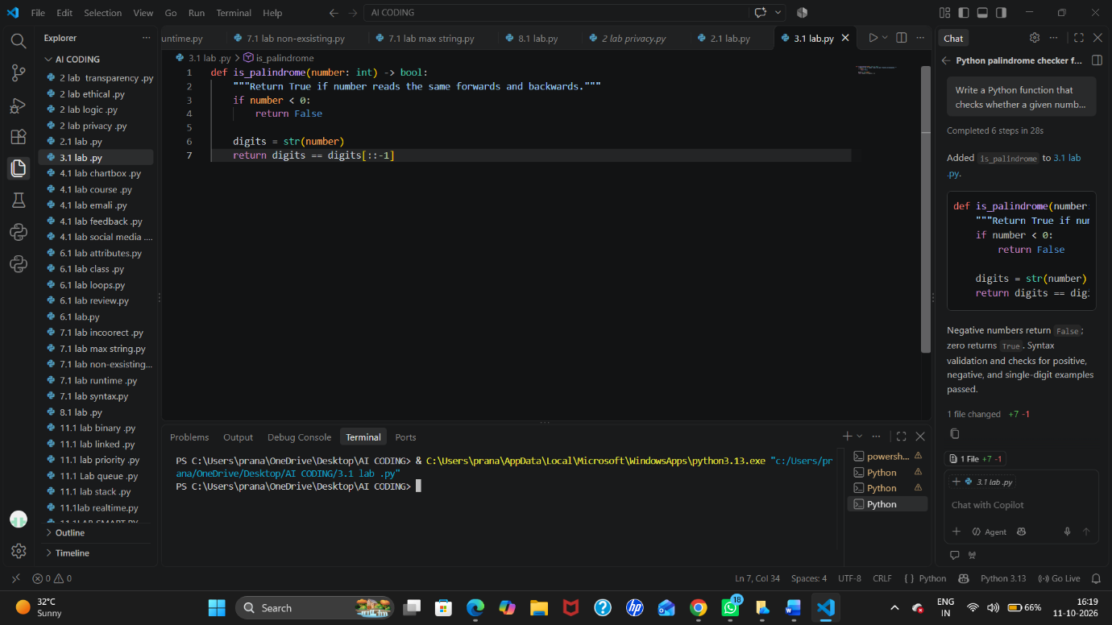

Question 2: One-Shot Prompting (Factorial Calculation)
Write a one-shot prompt by providing one input-output example and ask the AI to generate a Python function to compute the factorial of a given number.
Example:
Input: 5 → Output: 120
Task:
- Compare the generated code with a zero-shot solution.
- Examine improvements in clarity and correctness.
PROMPT: One-Shot Prompt

> Write a Python function to calculate the factorial of a given number. Use the following example as a guide: Input: 5 → Output: 120. The function should be clear, correct, and handle relevant edge cases.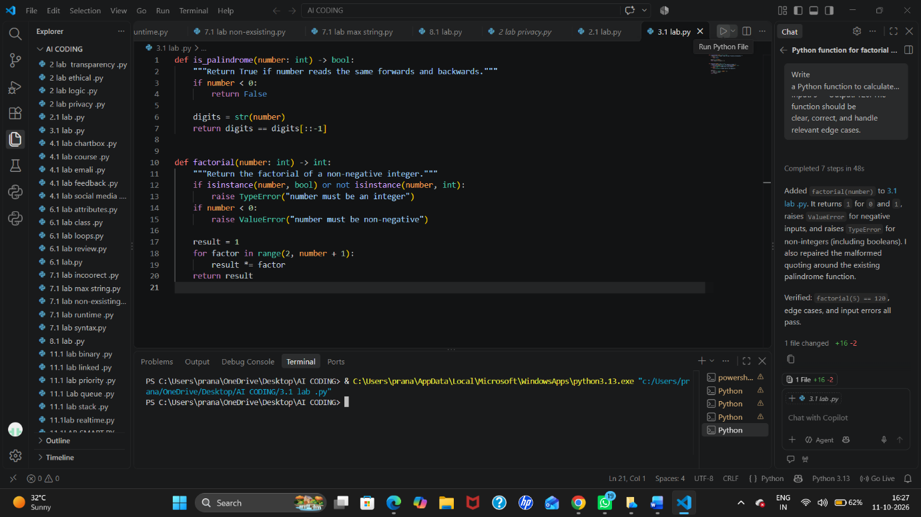

Question 3: Few-Shot Prompting (Armstrong Number Check)
Write a few-shot prompt by providing multiple input-output examples to guide the AI in generating a Python function to check whether a given number is an Armstrong number.
Examples:
- Input: 153 → Output: Armstrong Number
- Input: 370 → Output: Armstrong Number
- Input: 123 → Output: Not an Armstrong Number
Task:
- Analyze how multiple examples influence code structure and accuracy.
- Test the function with boundary values and invalid inputs.
PROMPT: Few-Shot Prompt

> Write a Python function to check whether a given number is an Armstrong number. Use these examples as a guide: Input: 153 → Armstrong Number; Input: 370 → Armstrong Number; Input: 123 → Not an Armstrong Number. The function should handle boundary values and invalid inputs.
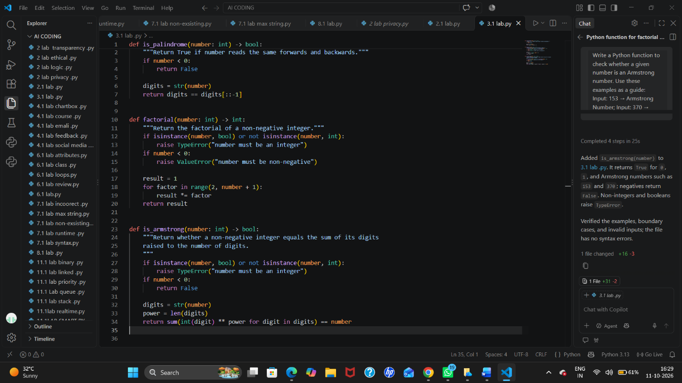

Question 4: Context-Managed Prompting (Optimized Number Classification)
Design a context-managed prompt with clear instructions and constraints to generate an optimized Python program that classifies a number as prime, composite, or neither.
Task:
- Ensure proper input validation.
- Optimize the logic for efficiency.
- Compare the output with earlier prompting strategies.
PROMPT: Context-Managed Prompt

> Write an optimized Python program that classifies a given integer as Prime, Composite, or Neither. Validate that the input is a valid integer. Treat numbers less than 2 as Neither. Optimize the prime-checking logic by checking divisors only up to the square root of the number. Provide clear, efficient, and readable code with appropriate output messages.

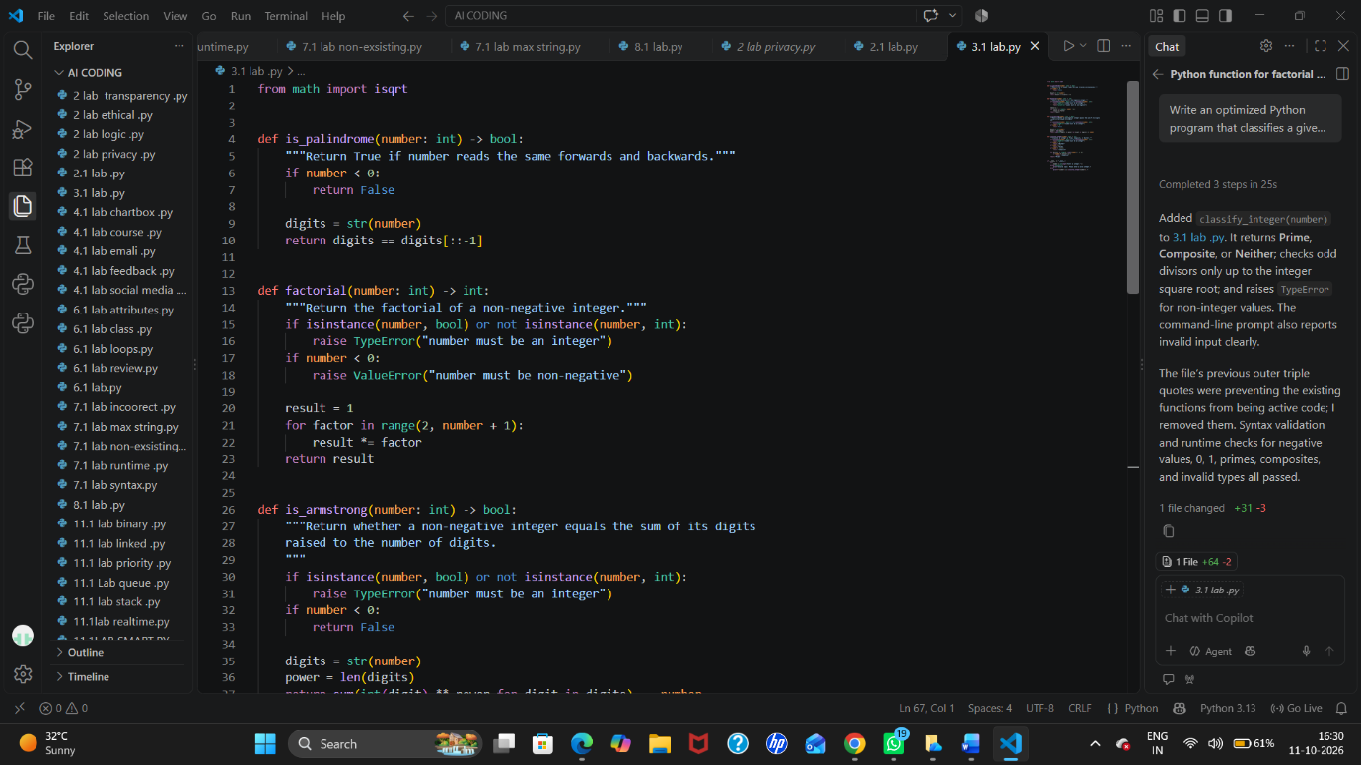
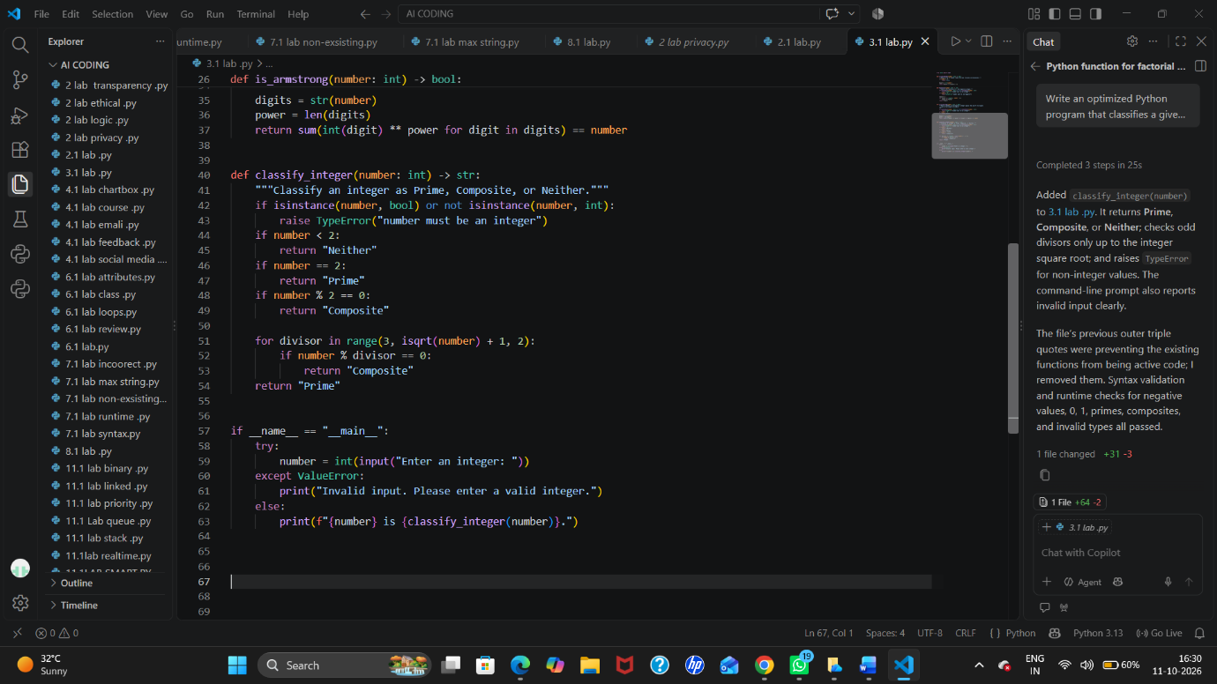
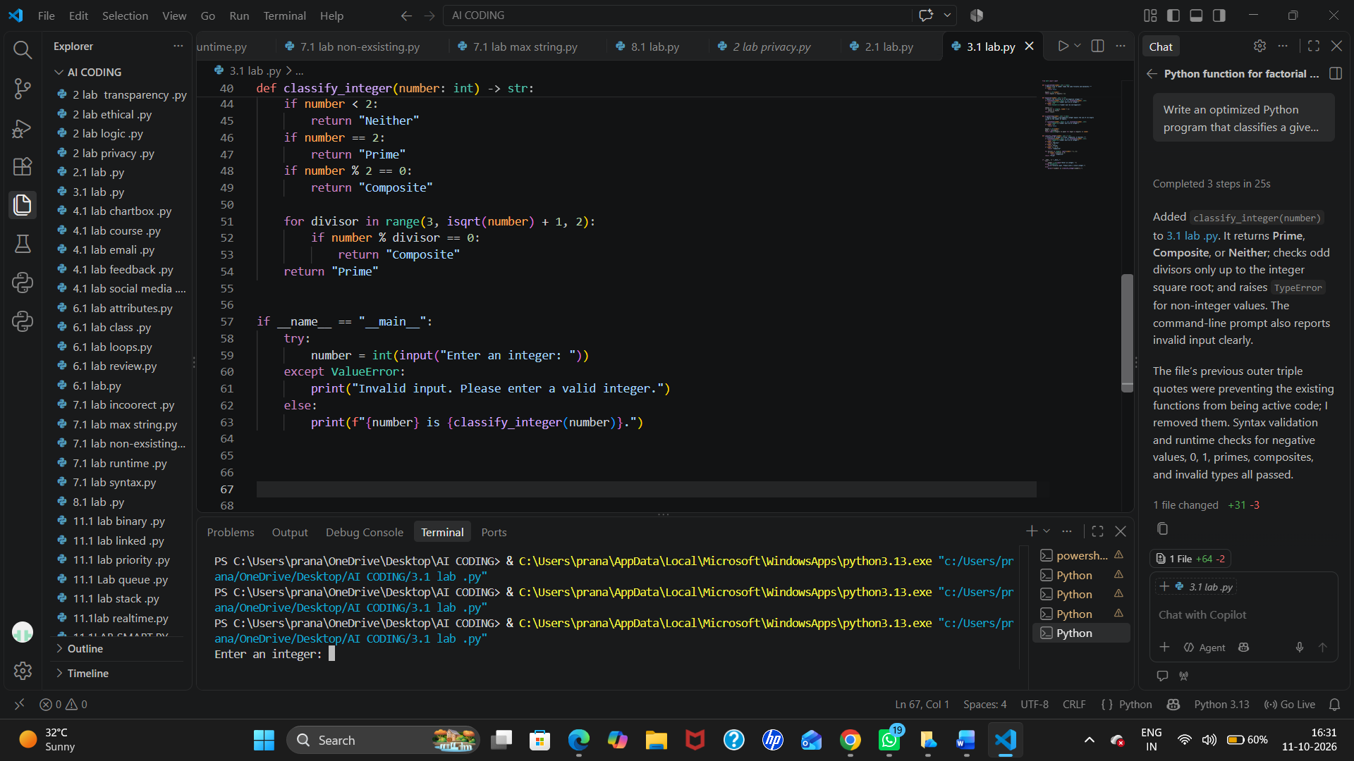

Question 5: Zero-Shot Prompting (Perfect Number Check)
Write a zero-shot prompt (without providing any examples) to generate a Python function that checks whether a given number is a perfect number.
Task:
- Record the AI-generated code.
- Test the program with multiple inputs.
- Identify any missing conditions or inefficiencies in the logic.
PROMPT: Zero-Shot Prompt

> Write a Python function that checks whether a given positive integer is a perfect number. The function should calculate the sum of its proper divisors and determine whether the sum is equal to the original number. Provide clear, efficient code and handle relevant edge cases.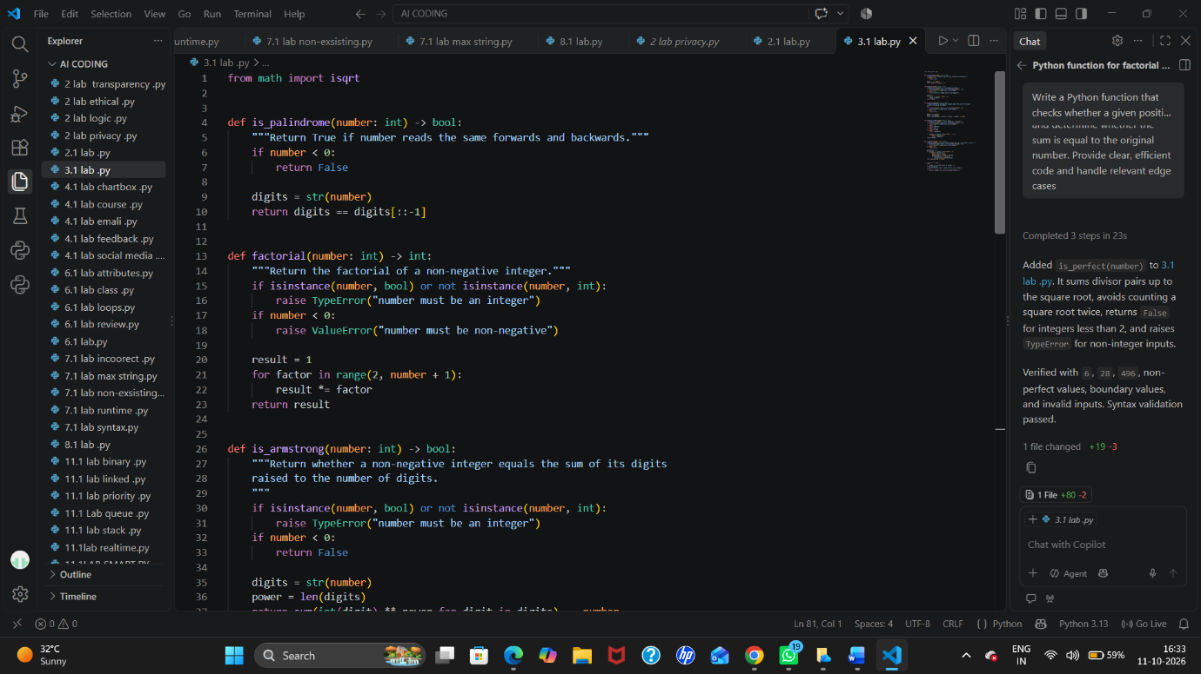
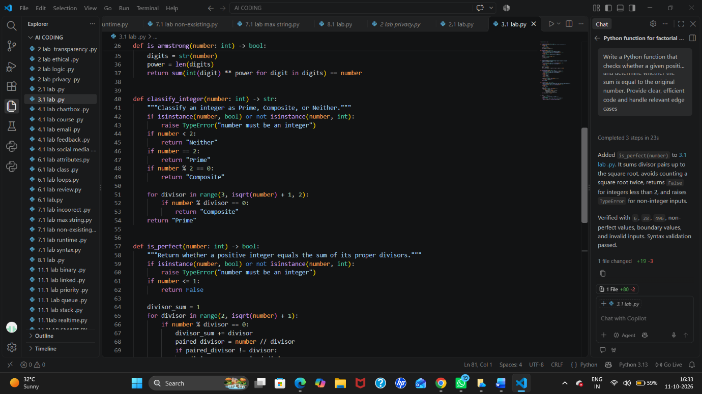
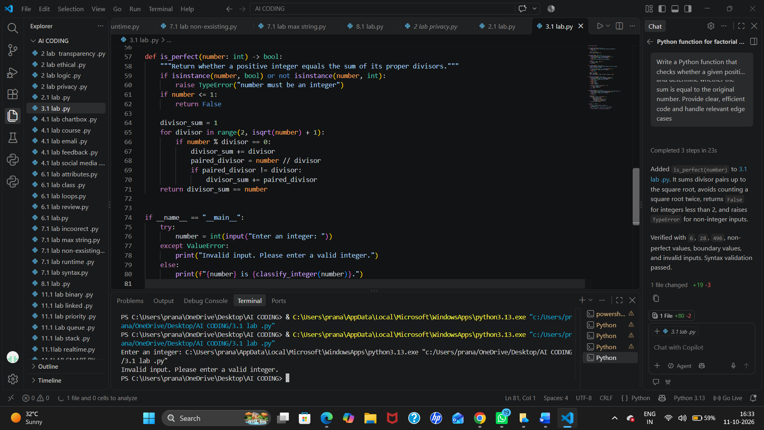
Question 6: Few-Shot Prompting (Even or Odd Classification with Validation)
Write a few-shot prompt by providing multiple input-output examples to guide the AI in generating a Python program that determines whether a given number is even or odd, including proper input validation.
Examples:
- Input: 8 → Output: Even
- Input: 15 → Output: Odd
- Input: 0 → Output: Even
Task:
- Analyze how examples improve input handling and output clarity.
Test the program with negative numbers and non-integer inputs
PROMPT: Few-Shot Prompt

> Write a Python program that determines whether a given number is even or odd, with proper input validation. Use these examples as a guide: Input: 8 → Even; Input: 15 → Odd; Input: 0 → Even. The program should also handle negative numbers and reject non-integer inputs with a clear error message.